**Class 11_01_2022**

**Graph Theory**

**UG Sem3**



**Operation on Graph**

1. Union
2. Intersection
3. Ring Graph
4. **Decomposition:**

A graph G is said to be decomposed into two sub graphs g1 and g2 if

g1 $∪$ g2=G

and g1 $∩$ g2= $∅$

Any edge of G either occurs in g1 or in g2 but not in both. How ever some vertices may occur in both g1 and g2.

If a graph has m edges {e1,e2,….em} then there are **2(m-1) -1 decomposition possible.**

**g1=0 g2=e1,…em** mC0

g1=e1 g2=e2….em mC1

g1=e1,e2 g2=e3,…em mC2

g1=e1,e2,e3 g2=e4,e5…em mC3

………………………..

g1=e1,e2,…..,em-1 g2=em mCm-1

g1=e1,e2,…..em  g2=0 mCm

mC0+mC1 + mC2 + mC3-------------------------------+ mCm-1+ mCm=2m

2(mC0+mC1 + mC2 + mC3---------+mCm/2)=2m

mC0+mC1 + mC2 + mC3---------+mCm/2=2m-1

1+mC1 + mC2 + mC3---------+mCm/2=2m-1

**mC1 + mC2 + mC3---------+ mCm/2=2m-1-1**

1. **Deletion. Deletion of a vertex u from graph G1**

**G –u.**

**Deleting u from G means deletion of vertex u along with all edges of G incident on u**

**If we delete an edge e from graph G i.e. we get a subgraph**

**G-e that is obtained by deleting edge e from graph G.**

**G-e=G $⨁$ e**

1. **Fusion(merge) of vertices.**

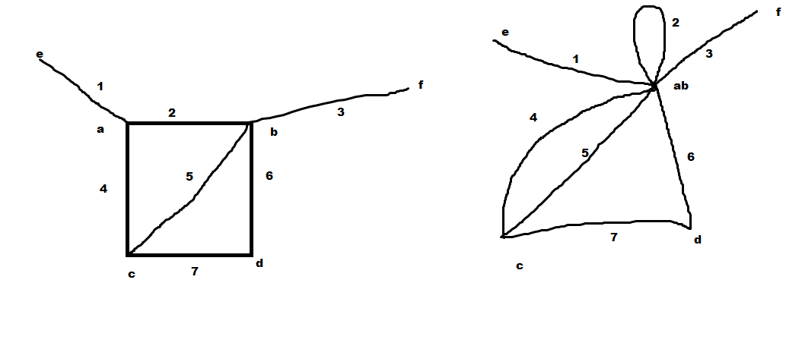

**Hamiltonian Graph:**

**A Hamiltonian graph G contains at least one Hamiltonian circuit.**

**A Hamiltonian circuit in a connected is a closed path in the graph which contains all the vertices of the graph.**

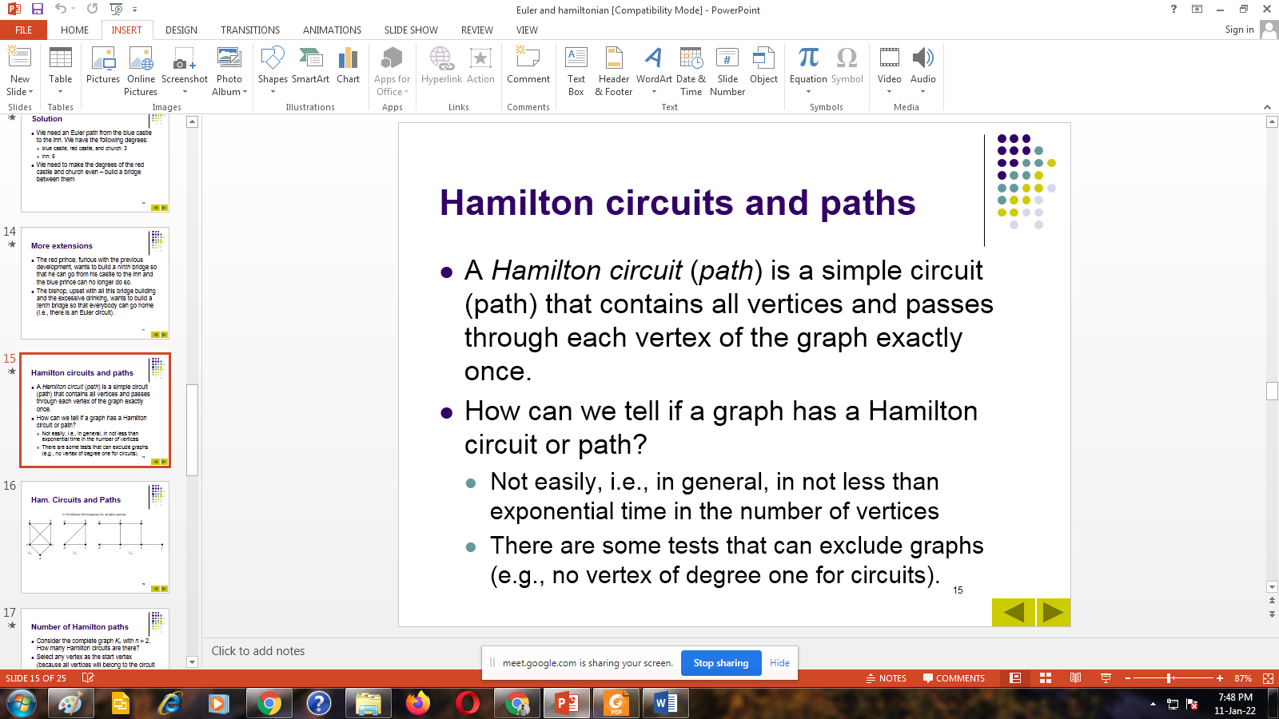

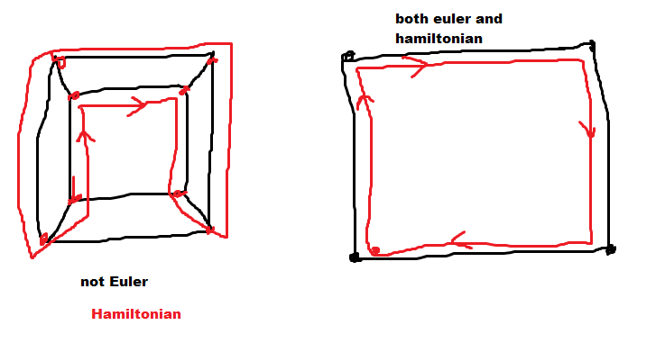

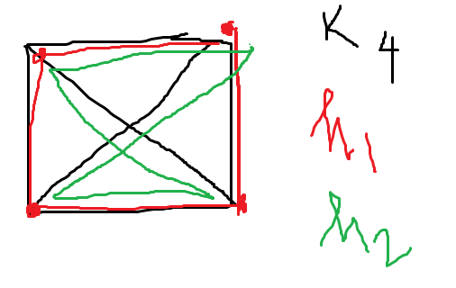

**Dirac Theorem:**A sufficient condition for a simple graph G to have a Hamiltonian circuit is that the degree of every vertex in G be at least n/2, where n is the number of vertices.

n-1>n/2 where n=3,4,….

Hence a complete graph is always Hamiltonian.

**Theorem:** In a complete graph with n vertices there are (n-1)/2 edge disjoint Hamiltonian circuit, if n is an odd number >=3.

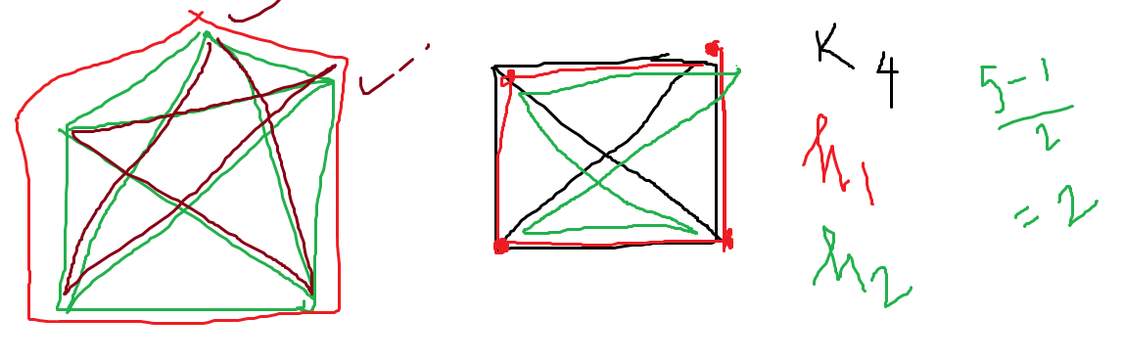

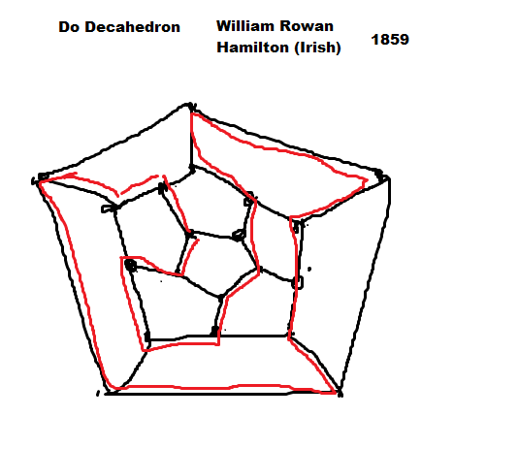

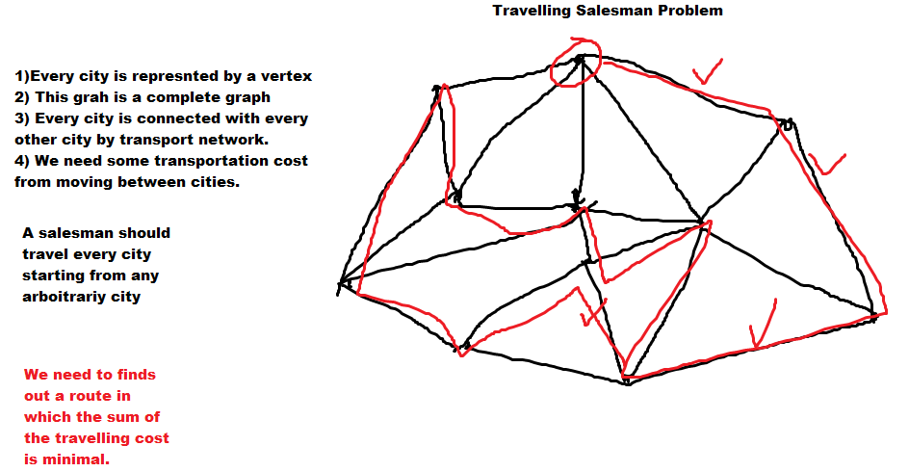



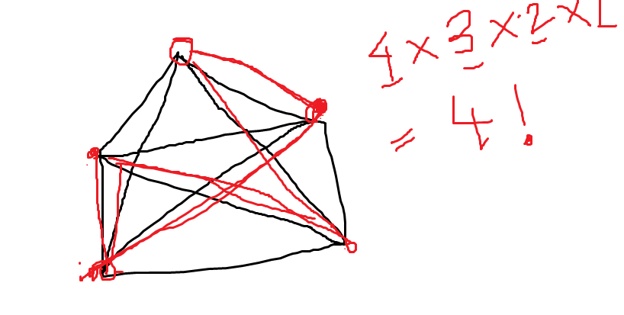

Total Hamiltonian circuits (n-1)!/2

O($n^{m}$) polynomial time

O($4^{n}$) Exponential algo

n!=O($n^{n}$)

n!=n*n-1*n-2*……1<=n*n*n…..*n=O($n^{n}$)

1+2+4+8+16+32+64+128+…………………………+

$2^{0}+2^{1}+2^{2}+……………………..+2^{63}$ =

$$2^{64}-1=8,446,744,073,709,551,616$$